心童裝 Heart Kids Wear - 網站系統開發規格書 (Website System Specification)
第一部分：前台系統設定 (Part 1: Frontend System Settings)
1. 帳號註冊與登入 (Account Registration & Login)
- 忘記密碼 (Forgot Password):
  - 中文： 註冊與登入畫面的右下角必須提供「忘記密碼」的選項。
  - English: A "Forgot Password" option must be provided at the bottom right corner of the registration and login screens.
- 註冊必填收件資料 (Required Shipping Info During Registration):
  - 中文： 使用者在註冊時即須選擇並填寫：收件門市、收件門市店號、收件人姓名（備註：請填寫證件姓名）、收件人電話。此欄位模式可參考原檔提供之 Google 表單連結。
  - English: During registration, users must select and fill out: Delivery store, Store number, Recipient's name (Note: Must match ID name), and Recipient's phone number. This field layout can refer to the Google Form link provided in the original file.
- 主要收件資料勾選 (Set as Primary Shipping Info):
  - 中文： 畫面上須提供一個可勾選的核取方塊（Checkbox），允許使用者將此資料設定為「主要收件資料」。
  - English: A checkbox must be provided to allow users to set this information as their "Primary Shipping Info".
- 其他會員基本資料 (Other Member Profile Data):
  - 中文： 包含個人姓名（註冊後不可修改）、出生日期、電話號碼、聯絡地址、電子郵件、登入密碼。
  - English: Includes Personal Name (Non-editable after registration), Date of Birth, Phone Number, Contact Address, Email, and Login Password.
- 驗證碼機制 (Verification Code Mechanism):
  - 中文： 系統發送驗證碼時，設定為傳送一次即可，註冊成功過後請勿持續或重複傳送。
  - English: The system should send the verification code only once. Do not continuously or repeatedly send verification codes after successful registration.
- 結帳自動帶入收件資料 (Auto-fill Shipping Info at Checkout):
  - 中文： 註冊並儲存 7-11 收件資料後，當客人前往結帳時，系統需直接自動顯示該資料，免除客人重新輸入的麻煩。若客人欲修改，欄位旁需提供一個「更改收件資料及門市」的按鈕，並提供 7-11 電子地圖連結（[https://emap.pcsc.com.tw/](https://emap.pcsc.com.tw/)）供客人自行查詢並填寫。
  - English: After saving 7-11 shipping info during registration, the system must automatically display this data when the customer checks out, so they don't have to re-type it. If they wish to change it, a "Change Shipping Info & Store" button must be available next to the fields, along with the 7-11 E-Map link ([https://emap.pcsc.com.tw/](https://emap.pcsc.com.tw/)) for customers to look up and fill in manually.
- 行銷管道調查與社群帳號 (Marketing Survey & Social Media Accounts):
  - 中文： 註冊時需填寫必填問卷：「如何知道我們？（可選擇 FB、IG 或 LINE 社群）」，並要求客人填寫其對應的 FB、IG 或 LINE 社群的帳號名稱。
  - English: A required survey question during registration: "How did you hear about us? (Options: FB, IG, or LINE Community)", and require customers to fill in their corresponding FB, IG, or LINE community account name.
- 電子郵件欄位說明文案 (Email Field Description Text):
  - 中文： 註冊填寫 Email 的地方需加上說明文字：「如有商品或訂單相關問題需要聯繫，如：缺貨是否願意更改尺寸或確認收件資料，會以訊息和 email 聯繫。」
  - English: The email field on the registration page must include the following explanatory text: "If there are any product or order-related issues that require contact, such as out-of-stock items, size changes, or shipping confirmation, we will reach out via system messages and email."
- 購物規則同意條款 (Shopping Rules Agreement Clause):
  - 中文： 註冊資料最後必須有一個核取方塊：「我同意且會配合心童裝的購物規則」。若使用者未勾選即點擊送出，系統需彈出視窗提示「請勾選我同意且會配合心童裝的購物規則」，且該視窗上須設有一個「關閉」按鈕。
  - English: At the end of the registration form, there must be a checkbox: "I agree to and will comply with Heart Kids Wear's shopping rules". If submitted without checking, a pop-up window must appear saying "Please check 'I agree to and will comply with Heart Kids Wear's shopping rules'", with a "Close" button on the window.
- 社群連結放置 (Social Media Links Placement):
  - 中文： 註冊頁面上需放置 FB、IG、LINE 社群的官方連結。同時，整個官網的頁尾（Footer/網站下方）也必須常駐這些社群連結。
  - English: Official links for FB, IG, and LINE community must be placed on the registration page. Meanwhile, these social links must also be permanently placed at the bottom of the website (Footer).
- 記住帳號功能 (Remember Me Feature):
  - 中文： 註冊與登入時需提供「記住帳號」的勾選框，讓使用者下次登入時不需要重新填寫帳號。
  - English: A "Remember Me" checkbox must be provided during registration and login, so users do not need to re-enter their account details next time.
- 登入失敗提示 (Login Failure Notification):
  - 中文： 若因帳號或密碼填寫錯誤而無法登入，系統需彈出錯誤訊息提示：「登入錯誤請再嘗試一次。」
  - English: If a user fails to log in due to an incorrect account or password, an error message must pop up: "Login error, please try again."
- 密碼顯示切換 (Password Visibility Toggle):
  - 中文： 登入密碼輸入框的右側必須設置一個「眼睛」圖案的按鈕，供使用者點擊以確認及顯示密碼是否輸入錯誤。
  - English: An "eye" icon button must be placed on the right side of the password field to allow users to toggle visibility and check for typos.
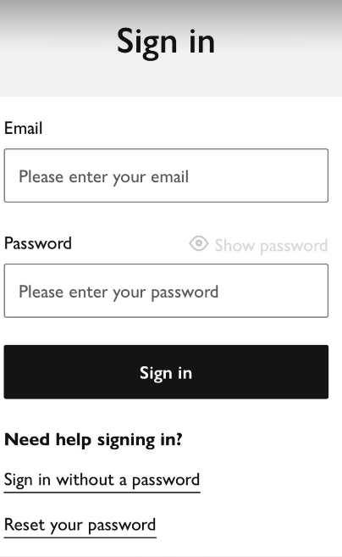

- Email 大小寫不敏感 (Email Case Insensitivity):
  - 中文： 輸入 Email 時，系統需自動處理，不論使用者使用大寫或小寫字母輸入皆可正常登入。
  - English: The email input field must be case-insensitive, allowing users to log in successfully regardless of capital or lowercase letters.
2. 網站首頁與全站通用介面 (Homepage & General Site UI)
- 金額顯示格式 (Currency Display Format):
  - 中文： 全站的金額顯示格式，統一由原本的 $1000 修改為 NT$1,000 格式。
  - English: The currency display format across the entire site must be unified from $1000 to NT$1,000.
- 公告橫幅 (Top Announcement Banner):
  - 中文： 網站最頂端一排需設計公告欄，文字內容為：「註冊首次送60點=7-11免運費。快來註冊看更多商品」。
  - English: An announcement banner must be designed at the very top of the website with the text: "Register now to get 60 bonus points = Free 7-11 shipping. Sign up to explore more items!"
- 購物車浮動預覽 (Shopping Cart Dropdown Preview):
  - 中文： 當商品放入購物車後，使用者點擊右上角的購物車圖案，需能直接預覽目前加入了幾件商品以及商品明細（包含照片、名稱、尺寸、數量、庫存狀態、小計等）。
  - English: When an item is added to the shopping cart and the user clicks the shopping cart icon in the top right corner, a preview must be displayed directly. This preview should show the total number of items currently in the cart, along with the item details (including photo, name, size, quantity, stock status, subtotal, etc.).
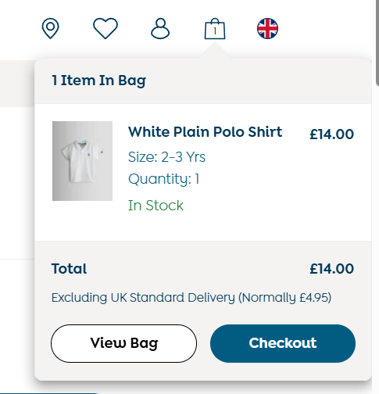
- 購物優惠提醒 (Discount Promotional Reminder):
  - 中文： 在「Add to Cart（加入購物車）」按鈕旁，需常駐顯示滿額優惠提醒文字：「滿4,000折60元優惠」。
- English: A permanent promotional reminder text, "Get NT$60 off on orders over NT$4,000," must be displayed adjacent to the "Add to Cart" button.

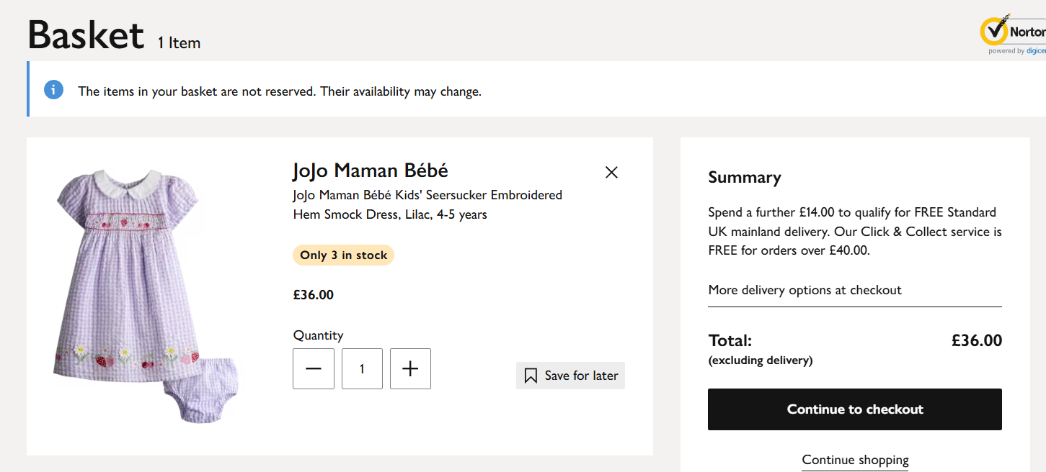
- 右上角功能導覽列 (Top Right Navigation Icons):
  - 中文： 網頁右上角需依序排列：購物車、♡ wish list (願望清單)、👤 登入人頭圖案、🔍 搜尋圖案。每個圖案點擊後皆會導向獨立的對應畫面。
  - English: The top-right corner of the webpage must display the following icons arranged in sequence: Shopping Cart, ♡ Wish List, 👤 Login/Profile, and 🔍 Search. Clicking on each icon must direct the user to its respective individual page or interface.
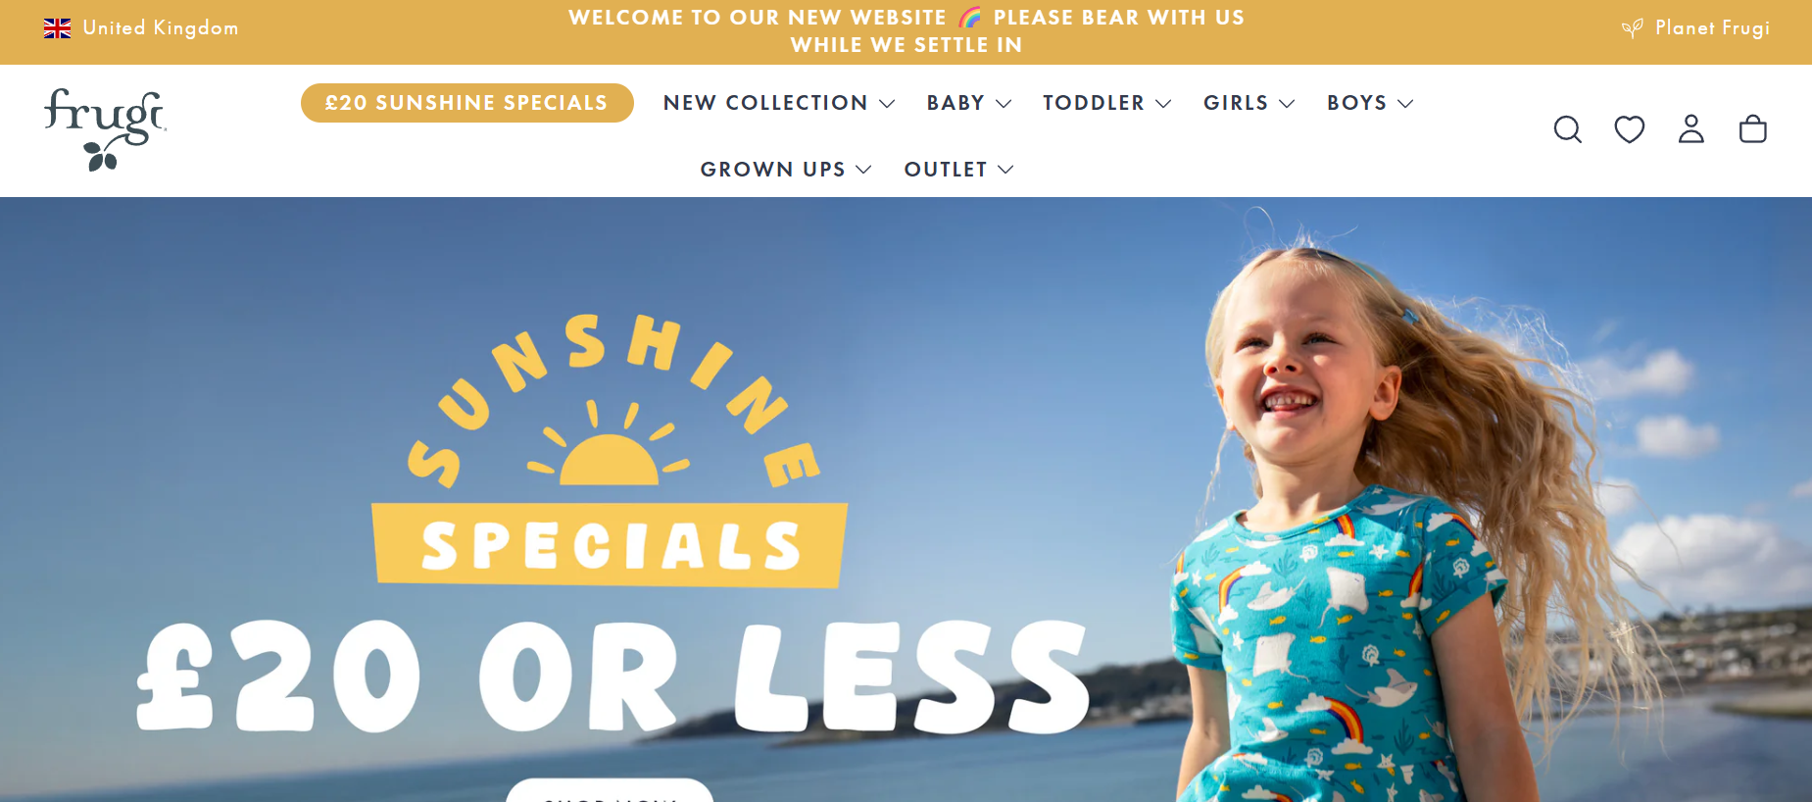
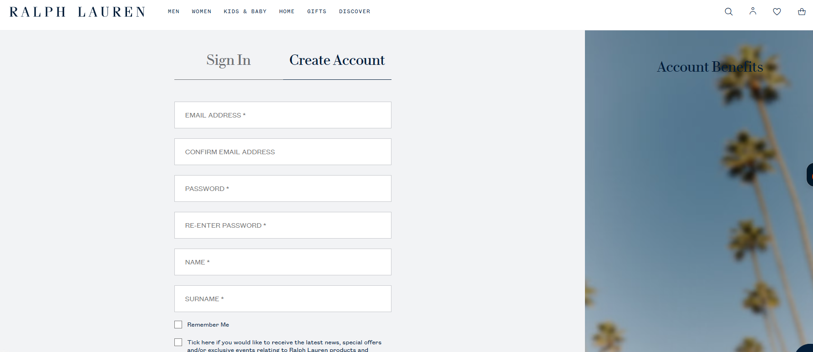
- 商標與回首頁功能 (Logo & Return to Homepage):
  - 中文： 不管使用者身處在網站的哪一個頁面，點擊位於左上角的「心童裝 Heart Kids Wear」大圖（Logo），皆須能直接回到首頁。
  - English: Regardless of which page the user is currently on, clicking the "Heart Kids Wear" logo located in the top-left corner must immediately redirect the user back to the homepage.
]
3. 會員個人中心 (Member Account Dashboard)
- 人頭選單下拉選項 (Profile Dropdown Menu):
  - 中文： 當已登入會員點擊右上角「人頭」圖案時，需可跳轉或下拉顯示以下選項：預購清單（Orders history）、過去購買訂單（Buy again）、對話紀錄（Messages，點選進入後可留言，且系統自動發送 email 告知「72小時內回覆」）、我的帳戶、登出。介面採左右分欄：左邊為選項選單，右邊為對應內容。
  - English: When a logged-in member clicks the "Login/Profile" icon in the top-right corner, a dropdown menu or page redirection must be triggered to display the following options: Orders History, Buy Again, Messages (where users can leave comments, and the system will automatically send an email stating "We will reply within 72 hours"), My Account, and Log Out. The interface must utilize a split-column layout: the left side displays the option menu, and the right side displays the corresponding content.
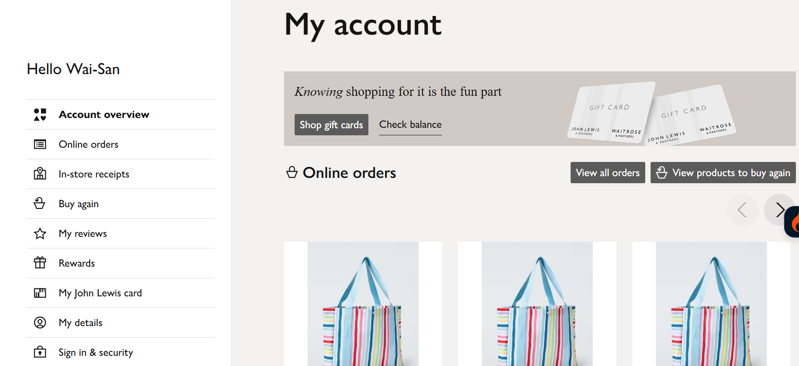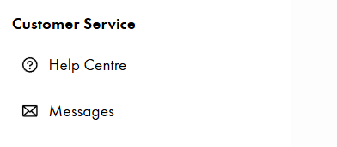
- 在個人頁面要設定左邊下來選單，分別是
預購清單Orders history-
類似下面的排版
English:
- On the user profile page, a left navigation dropdown menu must be configured, featuring the following option:
  - Orders history (預購清單)
  - Layout format should be similar to the reference below:

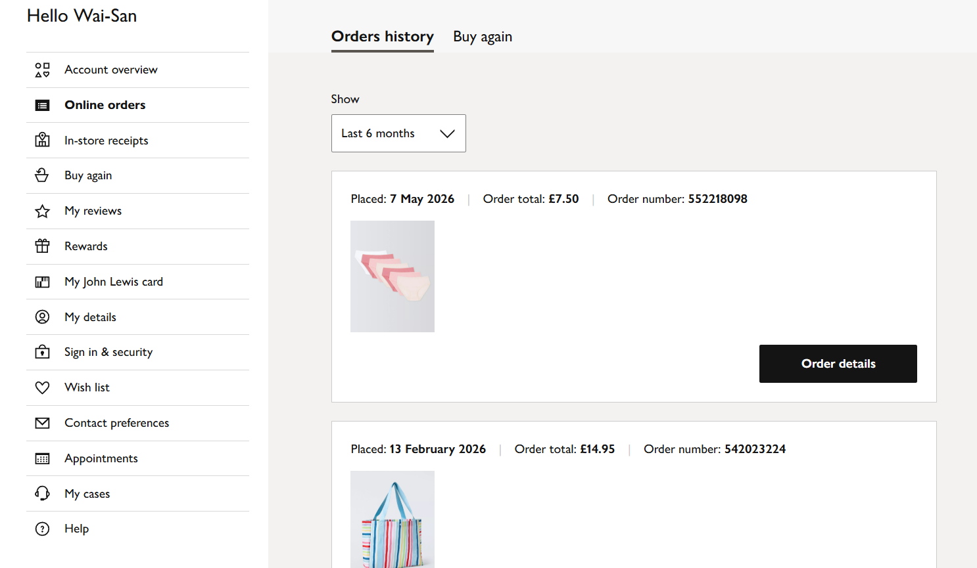

商品照片>商品名稱>款式>規格>數量>預購狀態(分處理中、已登記、斷貨)。
English:
The column layout for the product list must be ordered sequentially as follows: Product Photo > Product Name > Style > Specification > Quantity > Pre-order Status (categorized into: In Progress, Registered, and Out of Stock).
  - 後台備註連動機制： 每個商品的預購狀態後方需設有兩格備註欄。一格為「給客人看的備註（會員同步看到）」，另一格為「只有管理員自己看得到的備註（會員無法看到）」。若狀態為「處理中」，管理員可填寫原因（例如：目前缺貨待有機會補貨加單、或我還沒有購買或還沒有到貨）以便會員即時掌握。
English:
Two distinct remarks fields must be provided next to the pre-order status of each item:
  - Customer-Facing Remarks: Notes entered here will be synced and visible to the member.
  - Admin-Only Remarks: Internal notes that are strictly visible to administrators and hidden from members.
  - If the item status is set to "In Progress," administrators can input specific reasons (e.g., "Currently out of stock, pending restock or additional order placement" or "Not yet purchased / Not yet arrived") to provide members with real-time status updates.

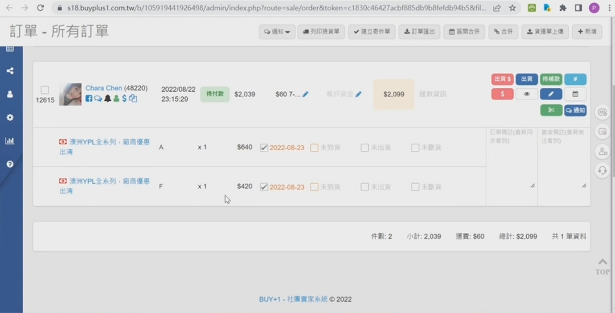
- 點數與購物金查詢 (Points & Store Credits Display):
  - 中文： 在個人預購清單及會員資料頁面中，皆須清楚顯示該會員目前累積的「剩餘點數」與「可用購物金金額」。
  - English: The member's current "Remaining Points" and "Available Store Credits" must be clearly displayed on both the pre-order list and member profile pages.
- 訂單詳細資訊欄位 (Order Details Fields):
  - 中文： 每個訂單頁面內需顯示：訂單編號、結帳日期、7-11 交貨便代碼（備註：郵局宅配則無此代碼欄位）、以及商品寄出日期。同時每個單品都要有其產品代號。訂單內附上的 7-11 交貨便代碼需做成可供客人直接點擊或複製查詢物流狀態的形式。
  - English：Each order detail page must display the following information: Order Number, Checkout Date, 7-11 Ship-to-Home (C2C/B2C) Tracking Code (Note: This field is not applicable and should be hidden for Post Office Home Delivery), and Shipment Date. Additionally, every individual item must display its specific Product ID.
The 7-11 tracking code provided within the order must be designed as a clickable link or a copyable text, allowing customers to directly track or query their logistics status.
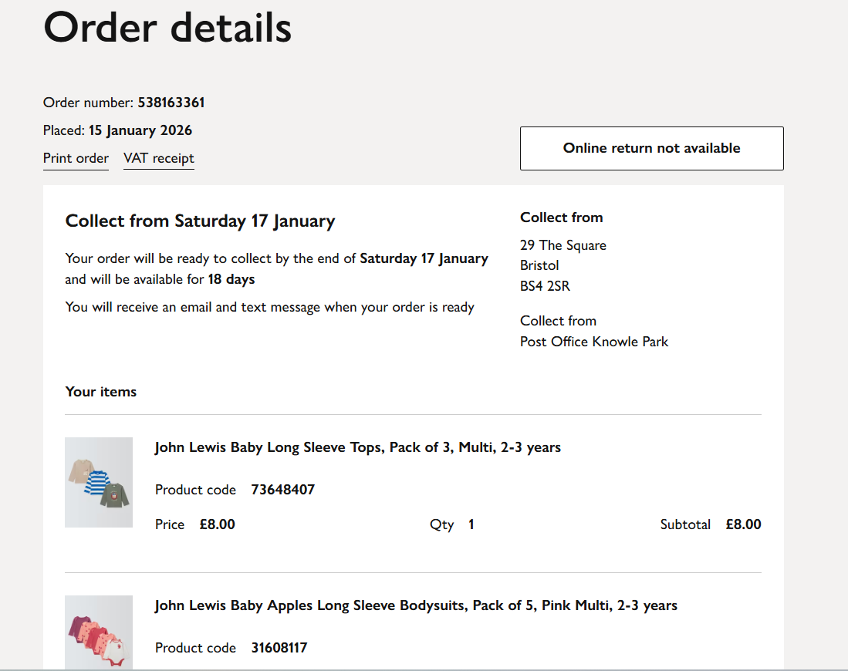
- 訊息與通知機制 (Messages & Notification Mechanism):
  - 中文： 當管理員主動發送訊息給特定客人時，系統必須同步觸發一封通知 Email 至該客人的電子信箱。此外，凡涉及「結帳」、「出貨」、「商品有問題」等重要系統狀態變更時，皆須有自動 Email 通知機制。
  - English: When the admin sends a message to a specific customer, the system must trigger a notification email to their mailbox. In addition, automatic email notifications are required for important status changes such as "Checkout", "Shipping", and "Product Issues".
- 我的帳戶 - 修改資料區塊 (My Account - Edit Profile Section):
  - 上方區塊（基本資料）： 顯示個人姓名（唯讀不可改）、出生日期、電話號碼、聯絡地址。
  - 下方區塊（進階修改）： 提供「更改收件資料」（內含 7-11 收件資料、郵局宅配收件資料與聯絡地址，並可設定任一組為預設收件資料）、更改電子郵件、更改密碼，以及查看點數與購物金。
• Top Section (Basic Information): Displays the user's Full Name (read-only, non-editable), Date of Birth, Phone Number, and Contact Address.
- • Bottom Section (Advanced Settings): Provides options to "Edit Shipping Information" (including 7-11 shipping details, Post Office Home Delivery shipping details, and contact addresses, with the ability to set any set as default), Change Email, Change Password, and View Reward Points & Store Credit.

- 登出功能 (Logout Feature):
  - 中文： 點擊後清除登入狀態並引導回首頁。
  - English: Clears login session upon clicking and redirects to the homepage.
4. 消費集點與購物金系統管理 (Points & Store Credits Logic)
- 購物金退款機制 (Store Credits Refund):
  - 中文： 當管理員在後台將商品勾選為「斷貨」時，系統需自動將該商品金額全額退回至該會員的帳戶購物金中。當該會員下一次購物結帳時，系統需在結帳頁面直接跳出「尚有多少購物金」，並在總金額中自動進行折抵，折抵後計算出最終需繳費的金額。若購物金大於訂單金額，折抵後需清楚標示「尚有多少購物金未使用」並留存於帳戶中。購物金設定為永久有效、無使用期限。
  - English: When the admin marks an item as "Out of Stock", the system must automatically refund the amount into the member's store credits. During their next checkout, the system must display "Available Store Credits" and apply it automatically to deduct from the total. If credits exceed the order amount, it must clearly state "Remaining unused credits" and keep the balance. Store credits have no expiration date.
- 消費集點回饋與過期通知 (Loyalty Points Rewards & Expiration):
  - 中文： （此功能預留，視開發進度可先做購物金，但架構需保留）消費集點依消費總額給予特定百分比回饋。例如：消費滿 1000 元回饋 0.2%。集點之 1 點等同於新台幣 1 元，使用期限為三個月。
  - 自動通知機制： 點數即將到期前，系統需主動發送訊息給客人，公版內容範例：「您有 [點數金額] 點尚未使用，在 [幾月幾號] 即將過期。若您喜歡我們的選品，期待再次為您服務。」
English:
- Reward Points Feature (Reserved Feature): (Note: This feature is reserved for future implementation depending on development progress; store credit may be prioritized, but the system architecture must support this framework). Reward points will be awarded based on a specific percentage of the total purchase amount. For example, a purchase of NT$1,000 will grant a 0.2% rebate. Each reward point is equivalent to NT$1, and points are valid for three months from the date of issue.
- Automated Notification Mechanism: Before reward points expire, the system must automatically send a notification to the customer.
  - Template Example: "You have [Points Amount] points remaining that are about to expire on [MM/DD]. If you enjoy our curated selection, we look forward to serving you again."

- 不定期活動點數發送 (Ad-hoc Bonus Points Issuance):
  - 中文： 管理員可從後台不定期手動發送點數給特定或全體客人（如：抽獎活動）。每張發送的點數卡皆可個別設定使用期限，且系統需限制結帳頁面一次最多只能使用一張點數卡。
  - English: Admin can manually issue points to specific or all customers for marketing (e.g., lucky draws). Each point card can have an individual expiry date, and the system must restrict a maximum of one point card usage per checkout.
5. 線上客服聊天室功能 (Live Chat Button - Chat with us!)
- 右下角對話按鈕 (Floating Chat Button):
  - 中文： 全站右下角需常駐「Chat with us!」功能按鍵圖案。點擊後將直接連結到個人的 Message 對話紀錄中。在首頁未點開時，僅顯示圓形對話圖示。
  - English: A "Chat with us!" functional button/icon must permanently reside in the bottom-right corner across all pages of the website. Clicking this button will link the user directly to their personal "Message" dialogue history. When on the homepage and not clicked or expanded, it should only display a circular chat icon.

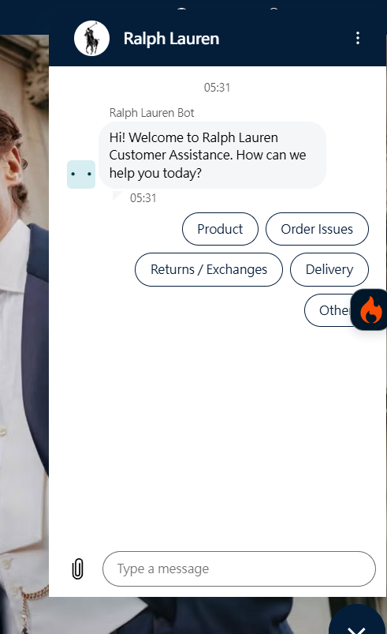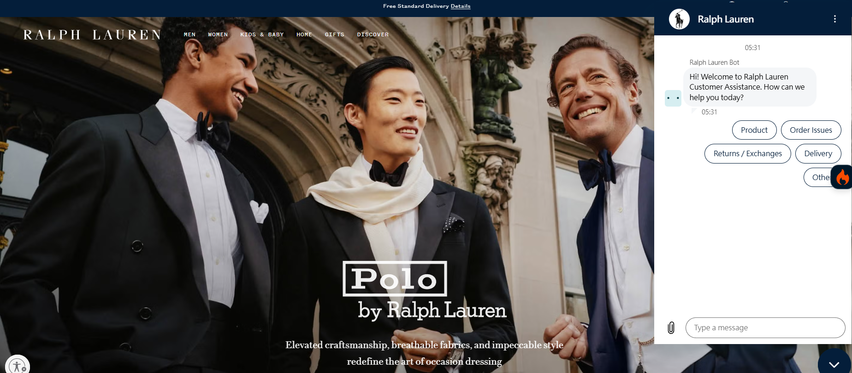
- 聊天室開啟介面與自動回覆 (Opened Chat Window & Auto-Reply):
  - 中文： 點開後的對話畫面同樣維持靠右側顯示。當客人發送訊息後，系統需自動觸發罐頭訊息回覆，內容如下：
「[客人姓名] 您好！歡迎光臨心童裝Heart Kids Wear。如果有任何問題請直接留言，我們會盡速回覆。💌 回覆順序由舊到新依序回覆，請勿重複留言，重複留言會讓順序往後推喔！謝謝！🙇🏻‍♀️」
English: Once opened, the chat window must remain aligned to the right side of the screen. When a customer sends a message, the system must automatically trigger a canned response with the following content:
"Hello, [Customer Name]! Welcome to Heart Kids Wear. Please feel free to leave your message here, and we will get back to you as soon as possible. 💌 We reply to messages in chronological order (from oldest to newest). Please refrain from sending repetitive messages, as doing so will push your inquiry back in the queue. Thank you! 🙇🏻‍♀️"
6. 購物車與結帳流程 (Shopping Cart & Checkout Process)
- 送出預購表單前確認 (Pre-order Form Confirmation Pop-up):
  - 中文： 當客人在購物車點擊送出預購表單時，系統必須彈出視窗提示：「我已確認款式、規格和數量，瞭解送出後無法更改或取消。」，客人必須強制勾選同意後方可繼續。
  - English: When a customer clicks to submit the pre-order form within the shopping cart, the system must trigger a pop-up window with the following prompt: "I have verified the style, specification, and quantity, and I understand that the order cannot be modified or canceled once submitted." The customer must be required to check an agreement box before they can proceed.
- 運送方式與運費階梯限制 (Shipping Methods & Restrictions):
  - 選項 A： 7-11 店到店（運費 NT$60），供客人自行選擇門市。
  - 選項 B： 郵局宅配（運費 NT$80）。
  - 數量限制邏輯： 當單筆訂單的商品總數量超過 15 項時，由於可能超過 7-11 寄件包裹體積限制，系統需強制鎖定只能選取「郵局宅配（運費 NT$80）」。台灣本島宅配實際費用雖介於 NT$80 至 NT$145 之間，但基於免運優惠承諾，超出 NT$80 的部分一律由店家負擔，故系統對客人的顯示與收取金額一律固定為 NT$80。
  - 這段中文與您稍早輸入的內容相同，以下為您提供專門針對這段「運送方式與數量限制邏輯」的獨立英文規格書內容：
English:
  - Option A: 7-11 Store-to-Store (Shipping Fee: NT$60): Allows customers to select their preferred pickup store.
  - Option B: Post Office Home Delivery (Shipping Fee: NT$80).
  - Quantity Restriction Logic: When the total number of items in a single order exceeds 15, the system must restrict and lock the shipping options, forcing the user to select "Post Office Home Delivery (Shipping Fee: NT$80)" due to 7-11 parcel volume and size limitations.
  - (Note: Although the actual domestic home delivery costs within Taiwan range from NT$80 to NT$145, based on the store's free-shipping/discount commitment, any amount exceeding NT$80 will be fully absorbed by the merchant. Therefore, the system must strictly display and charge the customer a fixed amount of NT$80).

- 結帳流程-
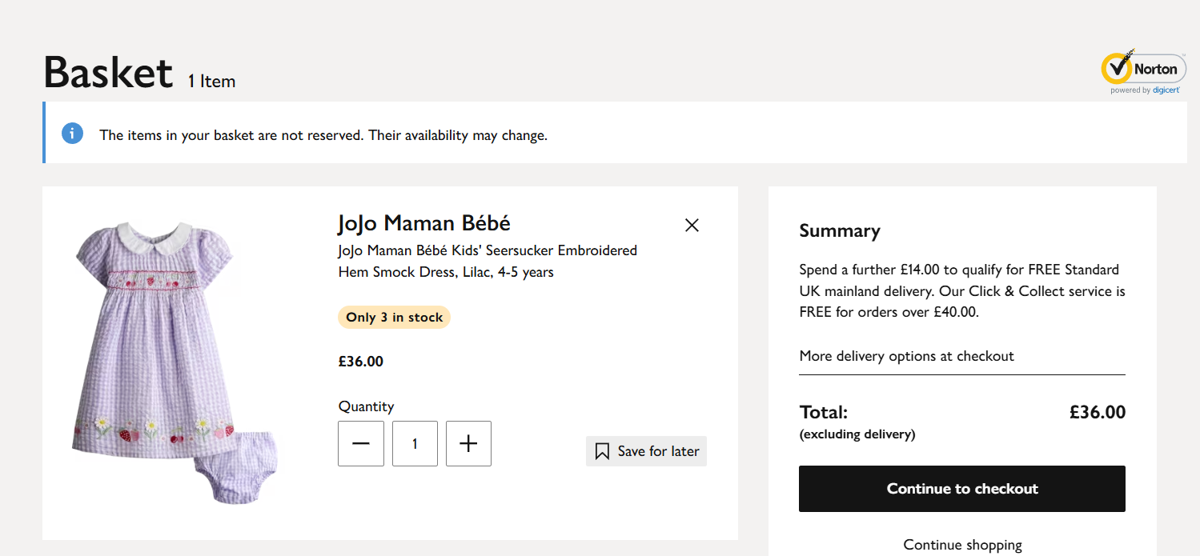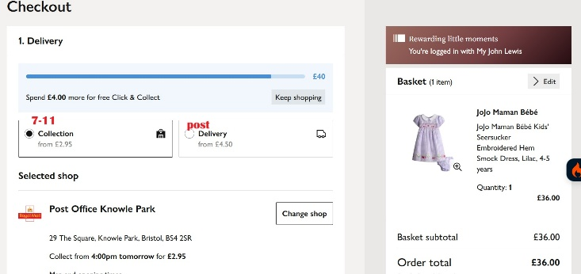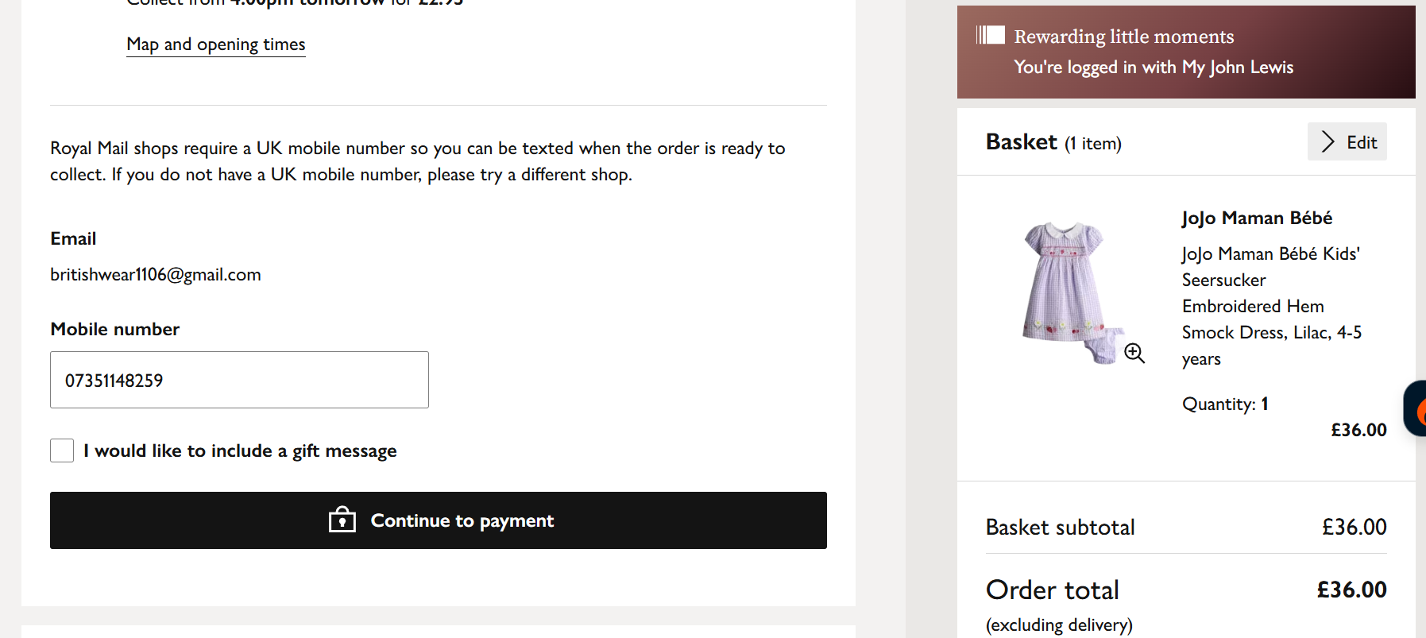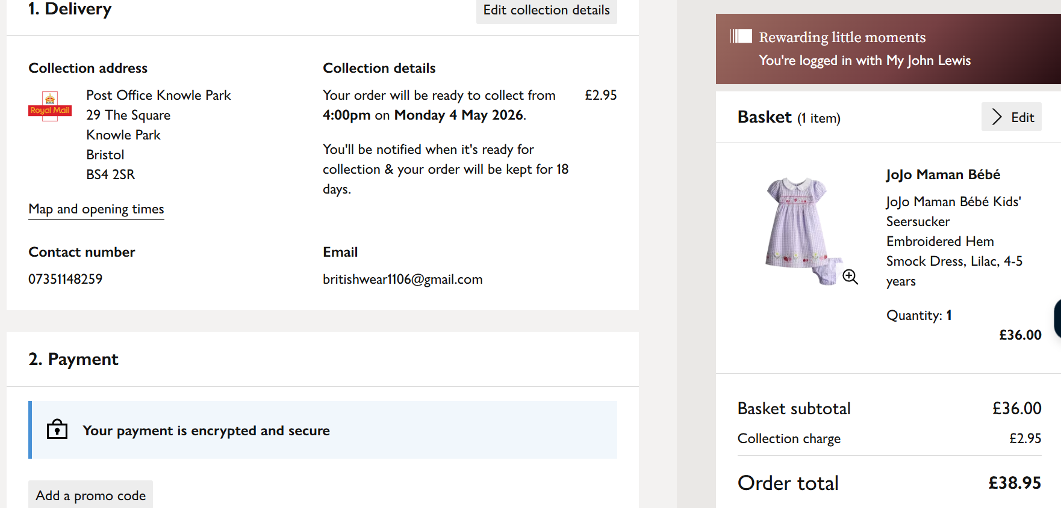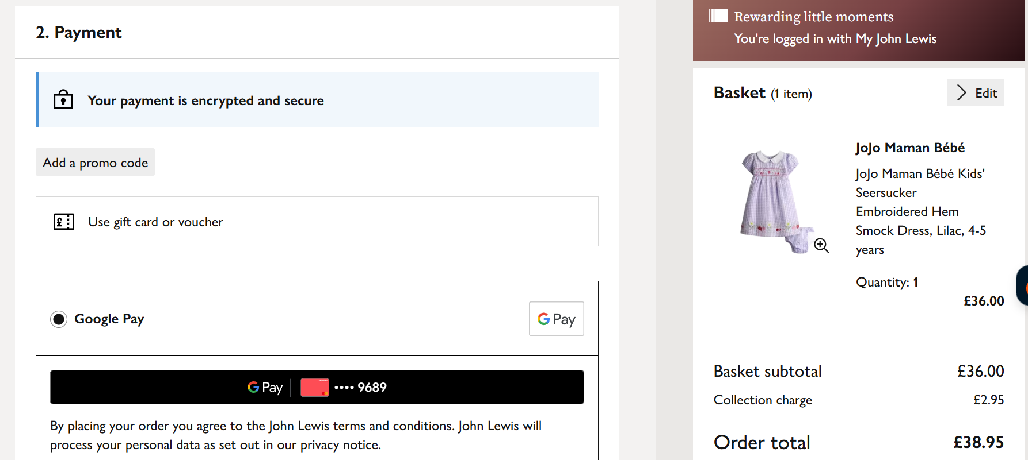
- 付款方式設定 (Payment Methods):
  - 主要方式： 採用虛擬帳號轉帳。當客人完成轉帳後，後台需與虛擬帳號系統連動，自動將訂單狀態更新為「已付款」，免除人工對帳程序，並讓客人在前端亦能即時查閱已付款狀態。
  - 信用卡付款： （目前暫不開通，後台程式架構需預留，待未來公司成立後再行開啟）。
English:
- Primary Payment Method (Virtual Account Transfer): A virtual account transfer system must be utilized. Once the customer completes the bank transfer, the backend must interface with the virtual account system to automatically update the order status to "Paid." This eliminates manual reconciliation processes and allows customers to view their updated payment status in real-time on the frontend.
- Credit Card Payment (Reserved Feature): (Note: This feature is currently suspended and will not be activated immediately. However, the system architecture and code framework must support this capability for seamless integration and activation in the future).

- 結帳地址多載與歷史紀錄 (Multi-address Checkout History):
  - 中文： 結帳頁面預設自動帶入會員資料中的收件地址，並提供下拉選單供快速勾選。若客人於結帳時修改了收件資料，系統需自動將此新地址紀錄儲存於該會員的帳戶歷史中。下次結帳時，下拉選單需列出歷史曾用過的多個選項供其快速選取。郵局宅配地址亦支援此下拉選單功能。
  - English: The checkout page must automatically populate the shipping address from the member's profile by default, while providing a dropdown menu for quick selection. If a customer modifies their shipping information during checkout, the system must automatically save this new address into the member's account history. For future checkouts, the dropdown menu must display multiple previously used addresses for rapid selection. This dropdown functionality must also be supported for Post Office Home Delivery addresses.
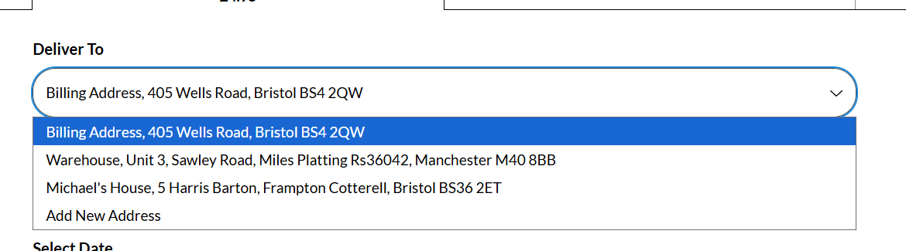
- 出國行程備註欄位 (Travel Schedule Reminders & Notes):
  - 中文： 結帳時需有顯眼提示文字：「🔸 若近期或下個月有出國行程，也請提前通知，以便協助調整出貨時間。」（參考原 Google 表單設計）。
  - English: A prominent notice text must be displayed on the checkout page as follows: "🔸 If you have upcoming travel plans this month or next month, please notify us in advance so we can assist in adjusting the shipment timing." (Reference: Original Google Form design).
https://docs.google.com/forms/d/1sUODynhp_IrvfaMjmp77TXKhQrBIgqwfXl1b2hM828E/edit?usp=drive_web&ouid=112579498432121087700
- 購物須知強制同意條款 (Terms & Conditions Mandatory Agreement):
  - 中文： 結帳按鈕上方需設置一個強制勾選框：「* I have read and accept the Terms & conditions（我已閱讀並接受《購物須知》）」。「購物須知」字樣需做成超連結，點擊可另開視窗觀看。未勾選此項前，下方的「立即支付 (PAY NOW)」按鈕為不可點擊狀態，點擊會跳出提示訊息要求必須勾選。
  - English: A mandatory checkbox must be placed directly above the checkout button, reading: "* I have read and accept the Terms & conditions (我已閱讀並接受《購物須知》)". The text "Terms & conditions" (購物須知) must be formatted as a hyperlink that opens in a new window/tab upon clicking.
- Until this checkbox is ticked, the "PAY NOW" (立即支付) button below must remain disabled (non-clickable). If a user attempts to click it while unchecked, a warning prompt must pop up requesting mandatory compliance.
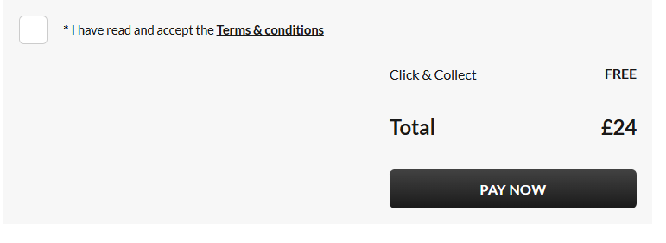
- 完成付款後提示彈窗 (Post-payment Success Notification Pop-up):
  - 中文： 付款成功後，系統需彈出包含以下文案的視窗，並附帶一個讓客人「自由填寫說明」的備註空格（如填寫具體出國日期以避開出貨時間）：
「🛎️ 出貨前提醒 - 若近期或下個月有出國行程，也請提前通知，以便協助調整出貨時間。🚚商品出貨後會傳送出貨通知。預購商品自『完成結帳及填寫完表單起約 3–6 週到貨』。商品抵達臺灣後會盡快為您寄出，謝謝您的耐心等候！感謝您選擇心童裝 Heart Kids Wear，謝謝支持！🙇🏻‍♀️❤️ 祝您順心愉快 😊」
English: Upon successful payment, the system must display a pop-up window featuring the text below, along with an open-ended, optional text field for the customer to input instructions (e.g., specifying exact travel dates to avoid conflicting shipment timing):
"🛎️ Pre-shipment Reminder - If you have upcoming travel plans this month or next month, please notify us in advance so we can assist in adjusting the shipment timing. 🚚 A shipping notification will be sent once your items are dispatched. Pre-order items typically arrive within approximately 3–6 weeks after checkout and form completion. Once the goods arrive in Taiwan, they will be shipped out to you as quickly as possible. Thank you for your patience! Thank you for choosing Heart Kids Wear, we truly appreciate your support! 🙇🏻‍♀️❤️ Have a wonderful day 😊"

- 逾期結帳限制與特殊帳號處理 (Overdue Checkout Restrictions):
  - 中文： 若訂單超過了規定的結帳期限，系統需自動關閉該訂單的信用卡與虛擬帳號轉帳功能。此時，結帳頁面僅能單獨顯示「國泰世華銀行自有名單帳號」，強制要求客人進行實體轉帳，且系統需強制流程：必須填寫完收件表單資料後，才能看到結帳總金額與國泰帳號，防止只轉帳不填單的情況發生。
  - English:
- Payment Method Restriction: If an order exceeds its designated payment deadline, the system must automatically disable both the standard Credit Card and standard Virtual Account transfer functions for that order.
- Forced Physical Transfer Flow: At this stage, the checkout page must exclusively display the store's "Cathay United Bank Static/Merchant Account" to mandate a physical/manual bank transfer.
- Sequence Control Logic: To prevent scenarios where customers transfer funds without providing shipping information, the system must enforce a strict conditional flow: the user must complete and submit the shipping form before the final checkout total and the Cathay United Bank account details are revealed.

- 訂單編號查詢依據 (Order Query Criteria):
  - 中文： 結帳完成後生成的訂單編號，將作為日後客人的主要查詢依據。客人可於客服系統中提供「訂單編號」、「姓名」與「Email」進行訂單狀態查核。
  - English: The unique order number generated upon successful checkout will serve as the primary reference for the customer's future inquiries. Customers can provide this "Order Number," along with their "Full Name" and "Email," within the customer service system to verify and audit their order status.
- 滿額折扣自動減免邏輯 (Automatic Bulk Discount Logic):
  - 中文： 結帳頁面需註明：「凡消費滿 4000 元（不含運費）訂單再折扣 60 元。如逾期結帳無法享有折扣 60 元優惠，訂單將於逾期隔天自動調整回原價。」 系統需自動偵測，凡滿足條件且未逾期之訂單，於結帳總金額自動減免 NT$60。
  - English:
- Checkout Page Notice: The checkout page must explicitly state the following notice: "🔸 For orders with a total purchase amount of NT$4,000 or more (excluding shipping fees), an additional discount of NT$60 will be applied. If the checkout window expires, this NT$60 discount will be forfeited, and the order will automatically revert to its original price on the day following the expiration date."
- System Automation Logic: The system must automatically detect and apply this rule. For any order that meets the NT$4,000 threshold and is completed within the valid payment window, the system must automatically deduct NT$60 from the checkout total. If the order expires, the system must dynamically remove the deduction and restore the original price.

第二部分：網站後台管理系統 (Part 2: Backend Management System)
1. 後台主選單架構 (Main Dropdown Menu Layout)
- 中文： 後台網頁左上角需設計一個可下拉的側邊主選單（功能清單排列順序由上至下如下）：
- English: A collapsible/dropdown sidebar main menu must be designed in the top-left corner of the backend web interface. The functional menu items must be arranged sequentially from top to bottom as follows:
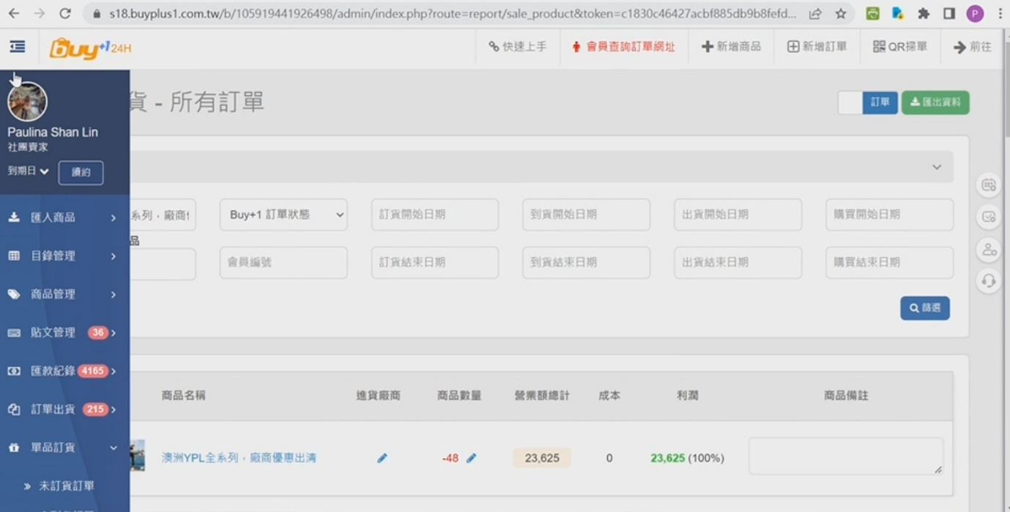
  - 匯入商品 (Import Products): 上架新商品設定。
    - 功能要求： 每個商品頁面內需可連結並匯入對應品牌的「尺寸表」供前端查閱。商品需支援「群組團（品牌開團）」分類，上架時可自訂不公開品牌名的團購標題（避免同行抄襲），並可在開團標題下方撰寫促銷文案（刺激購買文），下方才排列商品照片。
English:
- Size Chart Integration: Each product page must support linking and importing the corresponding brand's "Size Chart" for frontend user reference.
- Group Buying ("Brand Campaign") Classification: The system must support grouping products under specific "Group Buying (Brand Campaign)" categories.
- Customizable Hidden-Brand Titles: When launching a campaign, administrators must be able to customize a group-buying title that hides the actual brand name (to prevent competitors from copying the selection).
- Promotional Copy & Layout: The interface must allow administrators to write promotional/marketing copy directly underneath the campaign title to drive conversion, with the product images arranged sequentially below the text.
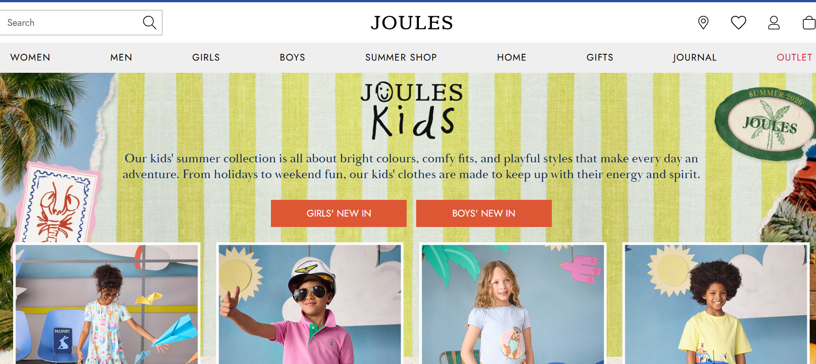
    - 分類歸檔： 支援兩層分類：第一層為性別/品項（男孩、女孩、男寶、女寶、其他（配件、玩具與書本））；第二層為「年齡分類」。
English:
- Category Hierarchy: The system must support a two-tier (two-level) category structure:
  - First Tier (Gender / Product Type): Boys (男孩), Girls (女孩), Baby Boys (男寶), Baby Girls (女寶), and Others (其他 - Accessories, Toys, and Books).
  - Second Tier (Age Classification): Age groups (年齡分類) corresponding to the respective selection from the first tier.

    - 排序功能： 前台商品列表右上角需提供「價格由低到高」與「價格由高到低」的切換功能。
English:
- Frontend Sorting Options: A toggle/dropdown menu must be provided in the top-right corner of the frontend product list page, allowing users to switch between "Price: Low to High" and "Price: High to Low" sorting views.

    - 代客下單功能： 管理員需具備在後台手動幫客（如 FB 留言下單者）新增訂單與單品加單的功能，並在完成後能通知客人登入網站進行結帳。
English:
- Order Placement on Behalf of Customers: Administrators must have the capability to manually create new orders within the backend on behalf of customers (e.g., accommodating customers who place orders via Facebook comments).
- Item Addition (Add-on Orders): The system must allow administrators to manually add specific individual items to a customer's existing order.
- Customer Notification: Upon completing the manual order placement or modification, the backend must support sending a notification to the customer, prompting them to log into the website to proceed with the checkout process.

  - 目錄管理 (Category Management): 統整與排程管理。
    - 功能要求： 支援「預約排定發佈時間」，時間到時整團或部分商品自動上架；結單時可設定批次或部分下架。下架商品需暫存於後台資料庫，以便未來廠商再次特價時，管理員可快速更新價格並重新一鍵上架。
English:
- Scheduled Publishing: The system must support a "Scheduled Release" feature, allowing administrators to preset a specific date and time for an entire group campaign or selected individual products to automatically go live on the frontend.
- Batch Delisting: Upon campaign closure, the system must support setting batch or partial product delisting based on custom administrative preferences.
- Product Archiving & One-Click Relaunch: Delisted products must be retained and safely stored within the backend database. This ensures that when a vendor offers a promotional discount in the future, administrators can quickly update the pricing and relaunch the items with a single click ("One-Click Relaunch").

  - 商品管理 / 單品訂貨 (Product Management / Item Logistics):
    - 管理與追蹤新訂單申請、現場採購進度。
    - 單品訂貨分類頁籤： 內部分為「未訂貨訂單」、「未到貨訂單」、「未出貨訂單」、「處理中訂單（已通知繳費，待付款未出貨）」。
English:
- Procurement Management & Tracking: The system must provide tools to manage and track new order requests as well as on-site sourcing/procurement progress.
- Item-Level Order Categorization Tabs: The internal management interface must feature dedicated tabs to classify and filter orders by their current fulfillment stage:
  - Unordered Items (未訂貨訂單): Orders that have been placed by customers but not yet processed/ordered from the supplier.
  - Undelivered Items (未到貨訂單): Items that have been ordered from the supplier but have not yet arrived at the warehouse.
  - Unshipped Items (未出貨訂單): Items that have arrived at the warehouse but have not yet been dispatched to the customer.
  - In-Progress Items (處理中訂單): Orders where the customer has been notified to make a payment, and the status is currently pending payment and shipment.

2. 所有訂單與進階配貨管理 (All Orders & Advanced Allocation Logistics)
- 商品配貨與對照視窗 (Product Allocation & Matching UI):
  - 中文： 在「所有訂單」管理介面中，可搜尋每項商品。畫面左側顯示該商品的配貨規格與數量（區分為未訂貨與已訂貨）；當管理員點選不同規格時，右側分欄需動態對照顯示「購買了該項規格的所有會員名單與狀態」。
English:
- Product Search Capability: Within the "All Orders" management interface, administrators must be able to search for every individual product.
- Dynamic Split-Screen Layout:
  - Left Panel (Allocation Specifications & Quantities): The left side of the screen must display the allocation specifications (e.g., size, color) and quantities for the selected product, clearly distinguished between "Unordered" (未訂貨) and "Ordered" (已訂貨).
  - Right Panel (Dynamic Member List & Status): When the administrator clicks on a specific specification in the left panel, the right panel must dynamically update to display a corresponding list of all members who purchased that specific variation, along with their current order statuses.
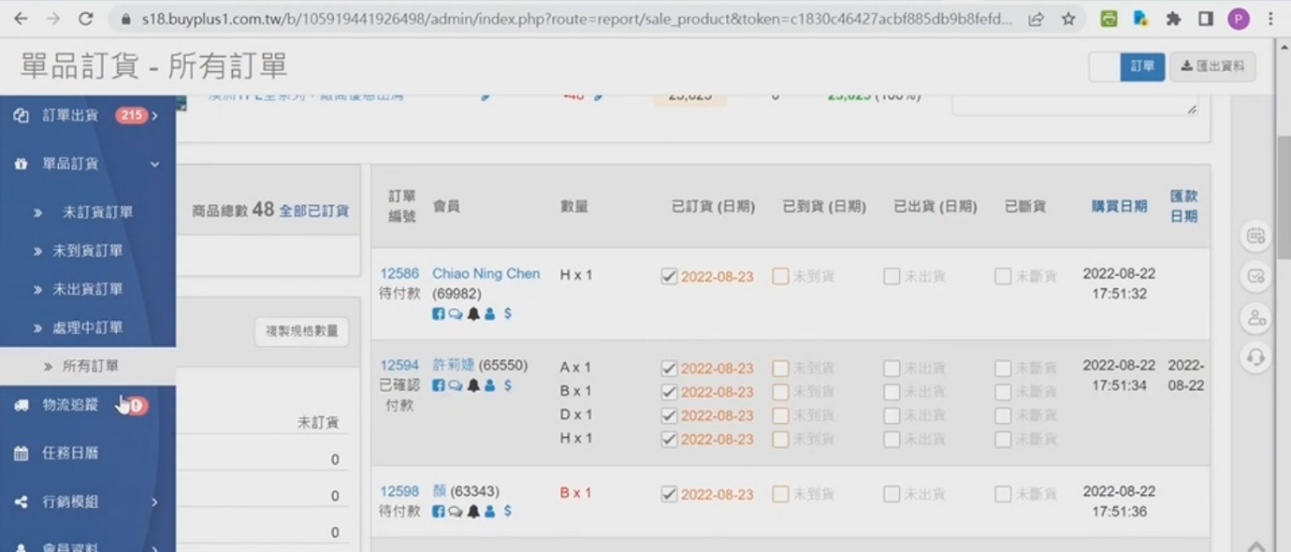
- 右側買家資訊欄位詳細定義 (Buyer Column Fields Details):
  - 訂單編號 (Order ID): 格式採「西元年後兩碼＋月份＋流水號」。例如 2026 年 4 月的第一筆訂單顯示為 26040001。編號下方需醒目提示「已確認付款」或「待付款」標籤。
English:
- Order ID Formatting: The system must generate the Order ID using the format: "Last two digits of the Western calendar year + Two-digit month + Sequential serial number."
  - Example: The first order placed in April 2026 must be displayed as 26040001.
- Visual Status Indicator: Directly beneath the Order ID, a prominent and eye-catching status label must be displayed, showing either "Payment Confirmed" (已確認付款) or "Pending Payment" (待付款).


  - 會員資訊 (Member Info): 顯示姓名與會員編號（依據首次購買年月排定，如 26 年 4 月第 4 位新客人為 2604004）。
English:
- Member Information Display: The interface must display the member's full name and unique Member ID.
- Member ID Formatting: The Member ID must be sequentially generated based on the year and month of the user's initial purchase.
  - Example: The 4th new customer who makes their first purchase in April 2026 must be assigned the Member ID 2604004 (Last two digits of the year + Two-digit month + Sequential customer number).

  - 快捷操作按鈕 (Quick Action Shortcuts): 會員姓名下方必須並列三個快速操作鍵：💬 訊息鍵（直接發送個人訊息）、👤 會員資料人頭鍵（查看詳細個資）、$ 金錢鍵（手動調整或發放購物金）。
English:
- Quick Action Buttons: Three parallel shortcut buttons must be displayed directly beneath the member's name:
  - 💬 Message Button: Initiates and sends a direct personal message to the member.
  - 👤 Profile Button: Opens and views the member's detailed personal information profile.
  - $ Store Credit Button: Allows administrators to manually adjust, credit, or issue store credit/reward points to the member's account.

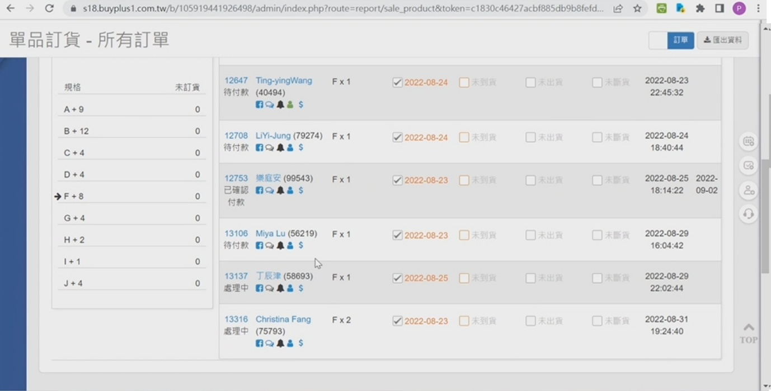
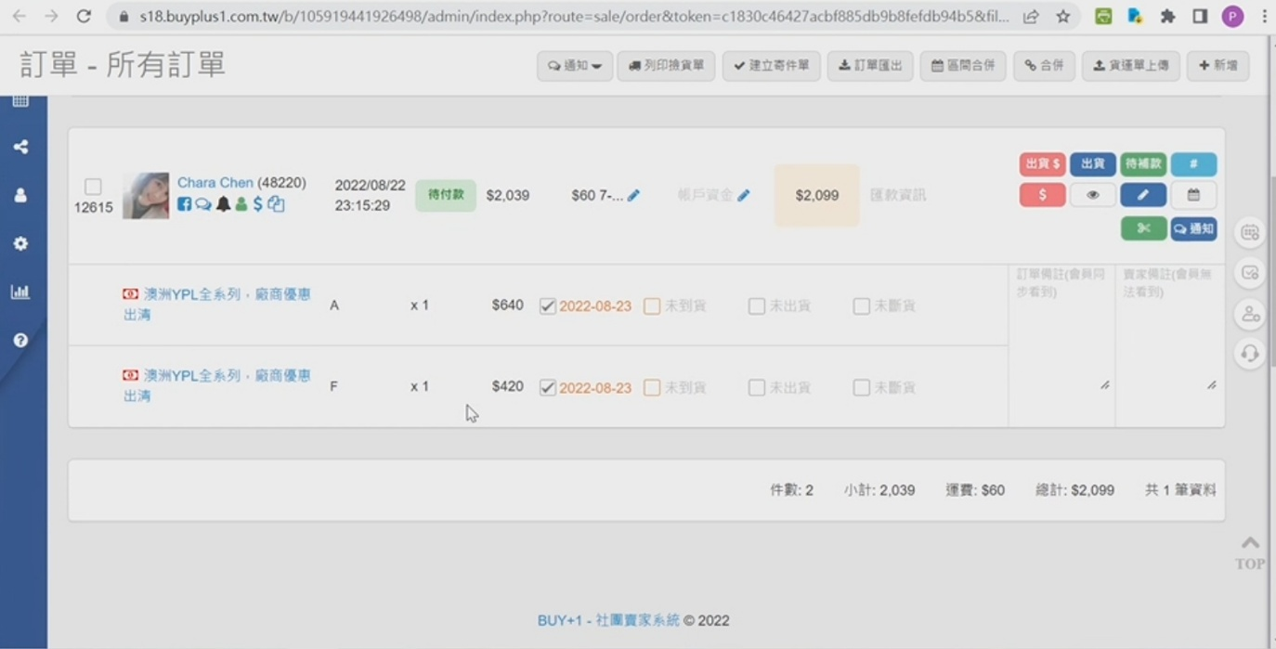
  - 會員姓名點選連動 (Member Profile Deep Link): 點擊姓名可點入其「個人總訂單頁面」，內含發送繳費日期、付款狀態、付款日期、訂單總額（未含運費）、以及下方的預購清單（包含單品價格、雙軌備註欄：一格給會員看，一格僅後台看）。
English:
- Member Profile Deep Link: Clicking on a member's name must deeply link to their individual "Comprehensive Member Order Page."
- Order Details Display: This dedicated page must display critical order milestones and tracking information, including:
  - Payment Reminder Sent Date (發送繳費日期)
  - Payment Status (付款狀態)
  - Payment Date (付款日期)
  - Order Subtotal (訂單總額 - excluding shipping fees)
- Pre-Order Itemization & Dual-Track Notes: A pre-order item list must be displayed at the bottom of the page, detailing individual item prices alongside a dual-track remark/notes system:
  - Client-Facing Notes Field: Visible to the member on the frontend.
  - Internal Notes Field: Restricted and visible exclusively to backend administrators.

  - 物流與採購動態追蹤方框 (Logistics Tracking Checkboxes): 欄位包含以下核取方塊，勾選後系統需自動帶入當天日期，亦允許手動覆蓋修改。未勾選時一律呈淺灰色文字提示：
    - 已訂貨(日期): 未填寫顯示「未訂貨」。
    - 已到貨(日期): 未填寫顯示「未到貨」。
已訂貨、已到貨請給我一個空格，讓我自行填寫日期，因為有時候同一個日期會買2-3次，我會註明2026/6/7(1)或2026/6/7(2)。
    - 瑕疵/破損日期: 需附帶一個手動填寫具體瑕疵狀況的備註欄；未勾選顯示「無瑕疵」。
    - 重買日期: 記錄重新採購日期；未勾選顯示「未重買」。
    - 斷貨日期: 若重買後依舊瑕疵/破損，則勾選此項確定斷貨（觸發退回購物金邏輯）；未勾選顯示「未斷貨」。
    - 寄回臺灣日期。
    - 裝箱色箱標記: 備註此商品是裝在哪一個顏色的箱子寄回臺灣。
English:
- Dynamic Date Generation Logic: The interface must include the tracking checkboxes detailed below. Upon ticking any checkbox, the system must automatically populate it with the current timestamp/date, while still allowing administrators to manually overwrite and modify the date. When unchecked, the respective item must display a light-gray placeholder hint.
- Tracking Checkbox Specification List:
  - Order Date [已訂貨(日期)]: If left blank, the frontend system must default to displaying "Not Yet Ordered" (未訂貨).
  - Arrival Date [已到貨(日期)]: If left blank, the frontend system must default to displaying "Not Yet Arrived" (未到貨).
Text Input Flexibility [自訂填寫與空格留白]:
Both fields must be configured as open/flexible text input fields (instead of a strict, restricted calendar date-picker widget).
This allows administrative personnel to manually input arbitrary text and custom alphanumeric markers to distinguish multiple distinct purchasing batches executed on the very same calendar day.
Example Formats Supported: 2026/06/07(1) or 2026/06/07(2).
  - Defective/Damaged Date [瑕疵/破損日期]: Must be accompanied by a manual text field to describe the specific defect condition. When unchecked, displays "No Defect" (無瑕疵).
  - Repurchased Date [重買日期]: Logs the date the item was re-ordered from the vendor. When unchecked, displays "Not Repurchased" (未重買).
  - Discontinued/Out of Stock Date [斷貨日期]: If the item remains defective or damaged after a repurchase attempt, checking this box confirms the item is officially out of stock (which automatically triggers the store credit refund logic). When unchecked, displays "Available" (未斷貨).
  - Shipped to Taiwan Date [寄回臺灣日期].
  - Color-Coded Shipping Box Tag [裝箱色箱標記]: A dedicated notes field to record which color-coded cargo box this item was packed into for its shipment back to Taiwan.

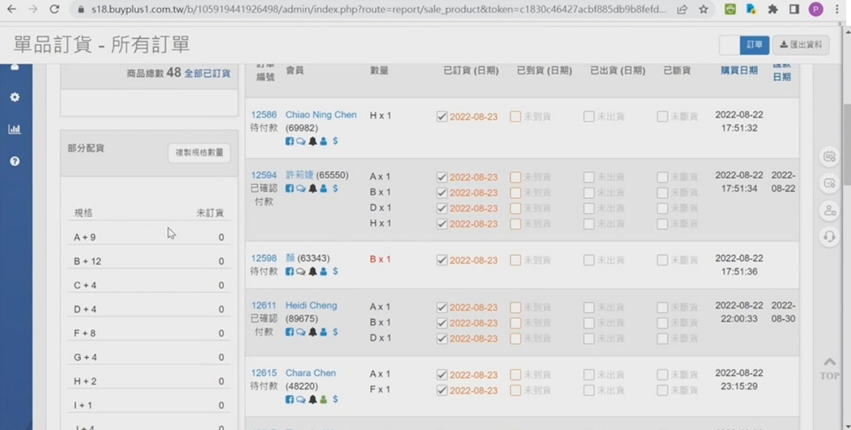
  - 提交預購時間 (Pre-order Submission Timestamp): 精確顯示至秒（格式：YYYY-MM-DD HH:MM:SS），此欄位為斷貨配貨先後順序的絕對依據。
English:
- Timestamp Precision: The pre-order submission time must be precisely displayed down to the second, using the format: YYYY-MM-DD HH:MM:SS.
- Allocation Priority Logic: This timestamp field serves as the absolute, definitive criterion for determining the priority sequence of inventory allocation and fulfillment in the event of stock shortages or discontinued items (斷貨配貨先後順序).

  - 付款日期 (Payment Date): 自動帶入虛擬帳號到帳日期，未付款則留白。
English:
- Automated Timestamping: The system must automatically populate this field with the exact date and time the funds are successfully received via the Virtual Account. If the order remains unpaid, this field must be left blank.

- 後台進階搜尋與篩選列 (Backend Advanced Search & Filter Bar):
  - 中文： 頂端需設置綜合篩選器，可透過以下維度進行交叉搜尋：商品名稱、產品代碼、會員姓名、會員編號、放購物車日期、網站訂購/現場購買日期、網站購買訂單編號與購買日期、到貨日期、瑕疵/破損日期、重買日期、重買到貨日期、斷貨日期、已通知斷貨備註、寄回臺灣日期、色箱備註。
  - English:
- Comprehensive Multi-Dimensional Filter: A global filtering panel must be positioned at the top of the interface, allowing administrators to perform advanced cross-searching and query combinations across the following criteria:
  - Product Attributes: Product Name (商品名稱), Product Code/SKU (產品代碼).
  - Member Attributes: Member Name (會員姓名), Member ID (會員編號).
  - Cart & Purchase Dates: Date Added to Cart (放購物車日期), Website Order Date / On-Site Sourcing Date (網站訂購/現場購買日期).
  - Order Specifics: Website Order ID & Purchase Date (網站購買訂單編號與購買日期).
  - Logistics & Procurement Milestones: * Arrival Date (到貨日期).
    - Defective/Damaged Date (瑕疵/破損日期).
    - Repurchased Date (重買日期) & Repurchased Item Arrival Date (重買到貨日期).
    - Discontinued/Out of Stock Date (斷貨日期) & Discontinued Notification Remarks (已通知斷貨備註).
    - Shipped to Taiwan Date (寄回臺灣日期) & Color-Coded Shipping Box Notes (色箱備註).

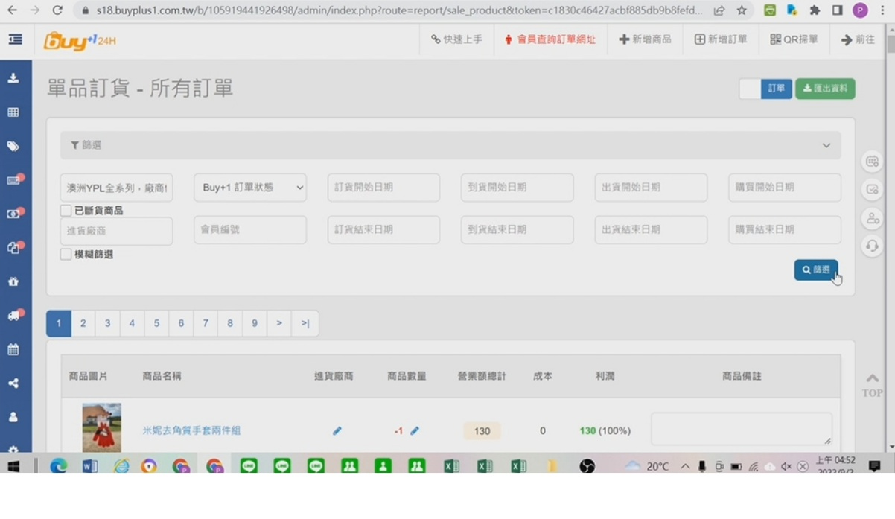
  - 單品搜尋結果欄位 (Product Search Result Fields): 若以商品進行搜尋，清單由左至右需呈現：商品照片、商品名稱、進貨廠商、商品數量、商品購買價格(英鎊)=成本、臺幣賣價、利潤（備註：此利潤暫不扣除國際運費）、商品備註。
English:
- Product-Based Search Layout: When searching by a specific product, the search result list must display the following data fields sequentially from left to right:
  - Product Image (商品照片)
  - Product Name (商品名稱)
  - Supplier/Vendor (進貨廠商)
  - Product Quantity (商品數量)
  - Purchase Cost (GBP) = Cost Price (商品購買價格(英鎊)=成本)
  - Retail Price (TWD) (臺幣賣價)
  - Profit Margin (利潤 - Note: This profit calculation temporarily excludes international shipping fees)
  - Product Remarks/Notes (商品備註)

  - 網站訂購日期單號標記 (Order Batch Labeling): 網站訂購日期後方需加上當日第幾單的註記（例如：2026/04/11 (1)），以便在國際包裹到貨時，精準對應採購批次與配貨客戶。
English:
- Purchase Batch Sequencing: The website purchase/ordering date field must be appended with a sequential daily order batch identifier (e.g., 2026/04/11 (1)). This identifier ensures that when international cargo arrives, administrators can precisely map and cross-reference the incoming procurement batch with the corresponding fulfillment customers.

  - 產品代碼獨立 SKU 邏輯 (Independent SKU Logic): 每個單品的不同規格/尺寸必須擁有「完全獨立的產品代碼（SKU）」。例如：湯瑪士短袖上衣的 2-3y、3-4y、4-5y 需分別各自擁有三個獨立代碼。
English:
- Unique Specification SKUs: Every individual product variant—including different specifications and sizes—must be assigned a completely "Independent Stock Keeping Unit (SKU) Code."
  - Example: For a "Thomas the Tank Engine Short-Sleeve Tee," the 2-3y, 3-4y, and 4-5y sizes must each possess their own distinct, independent SKU codes rather than sharing a single product identifier.
會員資料
會員資料裡面我有一格備註和一個事件時間軌。
備註的部份-我要備註這個人是否是愛遲繳的人，
事件時間軌-我要註明這個人過去曾經遲繳幾次? 斷貨退購物金幾次? 商品退回重寄幾次? 做一個時間軌，例如:幾年幾月幾號、發生事件
Member Profile: Administrative Notes & Event Timeline
會員檔案：管理員備註與事件時間軸系統
English Specifications:
- Administrative Delinquency Notes (備註欄位 - 交易行為標記):
  - The system must provide a dedicated, free-text administrative notes field within each member's profile backend.
  - This field is specifically designated for internal staff to tag and audit customer payment habits (e.g., explicitly noting whether the member is a chronic late-payer or reliable buyer: "本會員是否有慣性延遲繳款/愛遲繳之行為").
- Interactive Event Timeline (事件時間軌 - 歷史紀錄追蹤):
  - The profile must feature a chronological event log/timeline component that tracks and displays historical customer service and transaction milestones.
  - Each log entry on the timeline must dynamically capture and structure data into a standardized log format: [YYYY/MM/DD] - [Event Type] - [Detailed Description/System Notes].
  - Core Metrics & Event Types to Track (核心追蹤指標與事件類型):
The timeline component must automatically or manually audit, aggregate, and display the following events:
    - Overdue/Late Payment Events (遲繳次數紀錄): Logs every instance where the user failed to complete checkout before the standard deadline.
    - Out-of-Stock Store Credit Refunds (斷貨退購物金紀錄): Logs each occurrence where a pre-ordered item was discontinued by the supplier, and the corresponding procurement cost was refunded back to the user's account as store credit.
    - Returned & Reshipped Package Events (商品退回重寄紀錄): Logs instances where shipping packages were uncollected (e.g., at 7-11) and subsequently returned to the warehouse, requiring a secondary fulfillment process.
Database Schema Reference (後端資料庫欄位設計參考)
為了方便您的工程師建立資料表（Database Tables），以下提供建議的結構設計：
Field Name (欄位名稱) | Data Type (資料型態) | Description (說明)
admin_remarks | Text | 後台管理員備註（用以記錄是否愛遲繳等特殊行為）
timeline_id | PK (Auto-increment) | 時間軸事件唯一識別碼
member_id | FK (Foreign Key) | 關聯的會員編號
event_date | Date (YYYY-MM-DD) | 事件發生日期
event_type | Enum / String | 事件分類：LATE_PAYMENT (遲繳), STOCKOUT_REFUND (斷貨退購物金), PACKAGE_RETURNED (退回重寄)
event_description | Text | 事件詳細備註內容（例如：4月預購未取退回、5/2轉購物金$500）

3. 後台自動與手動訊息群發管理 (Messaging & Automated Reminders)
- 群發與個人訊息雙軌系統 (Bulk & Individual Messaging):
  - 個人訊息： 可針對特定客戶發送，並具備「已讀 / 未讀狀態查看功能」。前台會員登入後，其右上角人頭旁需有醒目的紅色數字氣泡提示未讀訊息數。
English:
- Targeted Individual Messaging: The system must allow administrators to send direct, private messages targeted to specific individual customers.
- Read/Unread Status Tracking: A tracking feature must be integrated into the backend, allowing administrators to monitor the "Read / Unread status" of each sent message.
- Frontend Notification Badge: Upon logging into the frontend, members must see a prominent red numerical notification bubble next to the profile/avatar icon in the top-right corner, indicating the exact count of their unread messages.
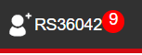
  - 群發訊息與變數套用 (Bulk Messages with Dynamic Variables): 可勾選特定多名會員進行批次群發，支援建立「公版內容（範本）」，且公版內需支援動態變數套用（例如自動將變數替換為每位客人各自的「名字」與「寄件編號」）。
English:
- Batch Bulk Messaging: The system must allow administrators to select multiple specific members via checkboxes to send batch broadcast messages simultaneously.
- Message Templates: The system must support the creation and saving of standardized message templates for reusability.
- Dynamic Variable Injection: The template engine must support dynamic variables that automatically parse and replace placeholders with each recipient's unique information (e.g., automatically injecting the customer's "Name" and "Tracking Number" into the corresponding fields of the message body).

- 逾期結帳階梯式催繳與棄單黑名單自動化邏輯 (Overdue Payment & Order Cancellation Logic):
  - 出單繳費通知控制： 管理員可在後台針對特定會員手動點選「發送 Email 通知繳費」。當管理員確認某會員訂購的所有商品採購無誤後，將訂單狀態改為「已確認」，系統隨即自動向該會員發送結帳通知訊息。
English:
- Manual Email Notifications: The system must allow administrators to manually trigger and send an "Email Payment Notification" to specific individual members from the backend interface.
- Automated Checkout Notifications: Once an administrator verifies that all products ordered by a specific member have been correctly procured and shifts the order status to "Confirmed" (已確認), the system must automatically dispatch a checkout notification message to that member.

  - 最後一天催繳通知（結帳截止日當天 - 系統自動發送）：
「哈囉您好：提醒您【今日 4/30 為結帳截止日】，再麻煩撥控結帳及完成表單回覆，謝謝您！」
English:
- Automated Trigger Logic: On the official checkout closing date, the system must automatically dispatch a final payment reminder to all members with pending balances.
- Notification Template (Message Body):
"Hi there! This is a friendly reminder that 【today, 4/30, is the checkout deadline】. Please take a moment to complete your checkout and submit the response form. Thank you!"

  - 逾期第一天緩衝通知（截止日隔天 - 系統自動發送）： 訂單狀態改為只能轉帳自行回報後五碼，三天內須結帳。
「哈囉您好：因恐您事務繁忙，以致尚未完成結帳。結帳緩衝期，超過結帳截止日三天內完成結帳，不會列入逾期未繳名單；若超過三天即視為逾期結帳。煩請盡速完成結帳及回覆表單。感謝您的理解與配合，謝謝您！」
English:
- Automated Trigger & Status Transition Logic: On the day immediately following the checkout deadline, the system must automatically execute two actions:
  - Restrict the member's payment options on the frontend to "Bank Transfer with Manual Reporting of the Last 5 Digits Only" (只能轉帳自行回報後五碼).
  - Set a strict 3-day hard deadline for checkout completion and dispatch the automated grace period notification.
- Notification Template (Message Body):
"Hi there! We understand you might be busy and may have missed the checkout deadline. You have now entered the checkout grace period. If you complete your payment and submit the form within the next three days, you will not be added to the overdue list. Payments made after this 3-day window will officially be marked as overdue. Please complete your checkout and submit the response form as soon as possible. Thank you for your understanding and cooperation!"

  - 逾期第三或第四天終極通知（最後緩衝日 - 管理員可手動或系統自動發送）：
「‼️最後結帳提醒，商品即將釋出‼️ 您好，您的訂單已超過結帳緩衝期尚未結帳。如今日未能完成結帳，將視為確定逾期結帳，商品釋出不保留，恕不再提供服務。以上告知。謝謝您！🙇‍♀️」
English:
- Trigger Mechanism: This final notice can be configured to be dispatched either automatically by the system or triggered manually by administrators on the final day of the grace period (Day 3 or Day 4 past the initial deadline).
- System Action (Upon Failure to Pay): If checkout is not completed by the end of the day, the system will automatically release the reserved inventory back into the stock pool and flag the account to restrict future ordering privileges ("Service Suspension").
- Notification Template (Message Body):
"‼️ Final Checkout Reminder: Items About to be Released ‼️ Hello, your order has exceeded the grace period and remains unpaid. If payment is not completed today, it will be officially treated as an overdue default; your items will be released without reservation, and we will no longer be able to provide services to your account. Please consider this our final notice. Thank you! 🙇‍♀️"

  - 黑名單自動標記： 若上述緩衝期過後仍未結帳，系統需自動執行：(1) 將該客戶帳戶註明「預期未結帳商品已釋出，視為棄單」。 (2) 後台訂單狀態更新為「被棄單」。 (3) 系統需統計並累計該會員的「逾繳次數」，作為多次棄單後終止服務的黑名單依據。
English:
- Automated Failure-to-Pay Actions: If the member fails to complete the checkout process after the aforementioned grace period expires, the system must automatically execute the following three backend actions:
  - Account Auditing Annotation [帳戶備註]: Append a system note to the customer's account profile stating: "The unpaid pre-ordered items have been released; this account is officially treated as an order default / ghosted order" (預期未結帳商品已釋出，視為棄單).
  - Order Status Update [訂單狀態更新]: Update the backend order status flag to "Abandoned / Defaulted" (被棄單).
  - Overdue Metrics Tracking [逾繳次數累計]: Calculate, increment, and log the cumulative "Overdue Count" (逾繳次數) for this member. This counter will serve as the programmatic basis for blacklist enforcement and eventual permanent termination of service for repeat offenders.

- 出貨與物流動態通知公版 (Shipping Notification Templates):
  - 7-11 出貨通知（公版變數套用）： 後台需內建此範本，其中「月份」與「寄件編號」由系統依訂單明細自動帶入，寄編亦需同步記錄於前端客戶的訂單明細中。
「【出貨通知】哈囉您好：您 [X] 月預購的商品已出貨，寄編 [M7788XXXXX]，查看包裹進度可以至 7-11 網站或 app 的交貨便查詢喔！7-11 也會有取貨簡訊，如怕遺漏請務必查詢包裹進度。🔺包裹如果未取被退回，需再寄出一次，第二次運費為 120NT，請特別留意。‼為保雙方權益，拆封包裹請錄影‼ ♻️環保愛地球，商品可能不會單獨包裝。如需裝箱，外箱可能使用回收紙箱（乾淨、衛生的），商品的完整度不受影響，特此說明。✨如果對商品有疑問，請與我們反應，我們會盡速回覆處理。收到商品很喜歡、很滿意的話，也歡迎給我們留下好評支持。🫶🫶🫶 感謝您選擇心童裝Heart Kids Wear，感謝您的購買！🙇‍♀️」
English:
- Automated Template Integration: The system backend must feature a built-in shipping notification template.
- Dynamic Variable Mapping: The system must automatically parse and inject the "Month of Pre-order" [X] and the unique "7-11 Shipping Tracking Number" [M7788XXXXX] from the order details into the message body.
- Frontend Synchronization: The generated tracking number must simultaneously be synced and displayed within the customer's order history on the frontend interface.
- Notification Template (Message Body):
"【Shipping Notification】Hi there! Your pre-ordered items from [X] Month have been shipped. Your tracking number is [M7788XXXXX]. You can track your package progress on the 7-11 E-Tracking website or app via the 'C2C Delivery Service' (交貨便)! 7-11 will also send a pick-up SMS notification; however, to ensure you don't miss it, please monitor the tracking status.
🔺 Please note that if the package is uncollected and returned to us, a resale shipping fee of 120 TWD will be charged for the second delivery attempt.
‼ To protect both parties' rights, please record a video while unboxing your package. ‼
♻️ Eco-Friendly Initiative: To protect our planet, individual items may not be wrapped separately. If boxing is required, we may use clean, sanitized recycled cardboard boxes; please rest assured that the integrity of your products will not be affected.
✨ If you have any questions regarding your items, please feel free to contact us, and we will respond as quickly as possible. If you love and are satisfied with your purchase, you are more than welcome to leave us a positive review for support! 🫶🫶🫶 Thank you for choosing Heart Kids Wear, and thank you for your purchase! 🙇‍♀️"

  - 7-11 未取貨催領通知（物流狀態連動）： 當系統偵測包裹已抵達門市且接近取貨截止日、客人仍未取件時，可發送此通知。
「【7-11取貨截止日為 YYYY/MM/DD】哈囉您好：您的包裹尚未至 7-11 取貨。可能 7-11 漏發簡訊通知您，請盡快撥控於截止日前前往領取。✨包裹如果未取被退回，需再寄出一次，第二次運費為 120NT，請特別留意。感謝您選擇心童裝Heart Kids Wear，感謝您的購買！🙇‍♀️」
English:
- Logistics Status Trigger: The system must actively monitor the 7-11 logistics API status. When it detects that a package has arrived at the destination store but remains uncollected as the pickup deadline approaches, this automated reminder must be triggered and dispatched to the customer.
- Notification Template (Message Body):
"【7-11 Pickup Deadline is YYYY/MM/DD】Hi there! Your package has not been picked up from the 7-11 store yet. It is possible that 7-11 missed sending you the automated SMS notification. Please take a moment to collect your package before the deadline. ✨ Please note that if the package is uncollected and returned to us, a resale shipping fee of 120 TWD will be charged for the second delivery attempt. Thank you for choosing Heart Kids Wear, and thank you for your purchase! 🙇‍♀️"

4. 付款紀錄、會員資料、與財務統計報表 (Finances & Member CRM)
- 付款紀錄管理 (Payment Logs):
  - 中文： 所有經由虛擬帳號或實體對帳成功的訂單，系統需自動歸檔至付款紀錄表單中，並提供按「年、月、日、具體付款時間」進行精確檢索的功能。
  - English:
- Automated Record Archiving: Upon successful reconciliation of payments via either Virtual Accounts or physical bank transfers, the system must automatically archive the corresponding order records into a dedicated "Payment History Ledger/Form" (付款紀錄表單).
- Multi-Dimensional Search & Retrieval: The archive management panel must provide precise search, filtering, and retrieval capabilities based on the following specific time dimensions:
  - Year (年)
  - Month (月)
  - Day (日)
  - Exact Payment Timestamp (具體付款時間)

- 會員資料庫管理 (Member CRM Profile):
  - 中文： 支援以「會員姓名」或「會員編號」進行快速搜尋。每位會員的詳細個資檔案內需完整記錄：會員名稱、編號、7-11 收件資料（門市/店號/收件人姓名/電話）、目前可用購物金、總購買次數、逾期未繳次數、購買歷史紀錄（按年月歸檔）、居住地址、Email、IG 帳號名稱、FB 帳號名稱、以及一個可由管理員自由填寫的後台備註欄（用以記錄客戶特殊交易行為或過往情況）。
  - English:
- Fast Query Execution: The system must support rapid searching and indexing of customer records utilizing either "Member Name" (會員姓名) or "Member ID" (會員編號) as the primary search keys.
- Comprehensive Profile Fields: Each member's detailed individual profile dossier must completely record and maintain the following data attributes:
  - Identity Information: Member Name (會員名稱), Member ID (編號).
  - Logistics & Fulfillment Details: 7-11 Delivery Information (7-11 收件資料)—including Store Name (門市), Store Code (店號), Recipient Name (收件人姓名), and Phone Number (電話).
  - Financial & Behavior Metrics: Current Available Store Credit (目前可用購物金), Total Purchase Count (總購買次數), Cumulative Overdue/Default Count (逾期未繳次數).
  - Historical Archives: Purchase History Log chronological ordered and archived by Year and Month (購買歷史紀錄按年月歸檔).
  - Contact & Social Handles: Residential Address (居住地址), Email Address (Email), Instagram Handle/Account Name (IG 帳號名稱), Facebook Profile/Account Name (FB 帳號名稱).
  - Administrative Auditing Field: An unconstrained backend administrative notes field (後台備註欄) allowing personnel to freely document customer-specific trading behaviors, historical edge cases, or past transaction anomalies.

- 成本與收支流水帳 (Cost & Expense Ledger):
  - 中文： 請參考原檔之記帳排版格式。系統需提供按月份區分的收支明細表。
  - 支出項目欄位： 日期、台幣金額、英鎊金額、備註欄（記錄物流到達時間、代採購溢買項目等）。需能手動分類輸入：妹妹薪水、英國本地運費、英台國際運費（需支援公式計算，如：17.25kg * 費率、體積重 (60*42*40cm)/5000 換算等）、包裝耗材支出（透明袋、破壞袋、LOGO 貼紙、膠帶、紙箱）。
  - 收入項目欄位： 收款日期、客戶姓名、台幣總收入。
  - English:
- System Layout & Monthly Segregation: Adhering to the original ledger's formatting and typography rules, the system must provide structured financial statements segregated cleanly by calendar month.
- Expense Sub-Ledger Fields (支出項目欄位):
  - Date (日期): The precise date on which the expenditure occurred.
  - Amount (TWD) (台幣金額): Cost denominated in New Taiwan Dollars.
  - Amount (GBP) (英鎊金額): Cost denominated in British Pounds, serving as the base currency for UK procurement operations.
  - Remarks (備註欄): A multi-purpose auditing notes field used to record logistics arrivals (e.g., Logistics Arrival Timeline) and purchasing anomalies (e.g., Sourcing Overflows / Over-ordered items).
- Manual Expense Categorization (手動分類輸入): The system must allow administrators to manually categorize costs into the following predefined operational accounts:
  - Assistant Salary (妹妹薪水): Local operational or assistant payroll.
  - UK Local Shipping (英國本地運費): Domestic inland freight and courier fees within the United Kingdom.
  - UK-to-TW International Freight (英台國際運費): Cross-border international shipping fees. This category must support dynamic formula execution, including:
    - Actual Weight Calculations: e.g., 17.25\text{ kg} \times \text{Rate}.
    - Volumetric/Dimensional Weight Conversions: Standard international logistics divisor formula: \frac{\text{Length} \times \text{Width} \times \text{Height (cm)}}{5000} (e.g., \frac{60 \times 42 \times 40\text{ cm}}{5000} = 20.16\text{ kg}).
  - Packaging & Consumables (包裝耗材支出): Material costs including OPP transparent bags (透明袋), poly mailers (破壞袋), branded logo stickers (LOGO 貼紙), adhesive tape (膠帶), and corrugated cardboard boxes (紙箱).
- Income Sub-Ledger Fields (收入項目欄位):
  - Payment Collection Date (收款日期): The exact calendar day the payment was successfully cleared and verified.
  - Customer Name (客戶姓名): Name of the purchasing member (mapped and linked to the Member Profile database).
  - Total Income (TWD) (台幣總收入): Gross revenue captured from the customer in New Taiwan Dollars.

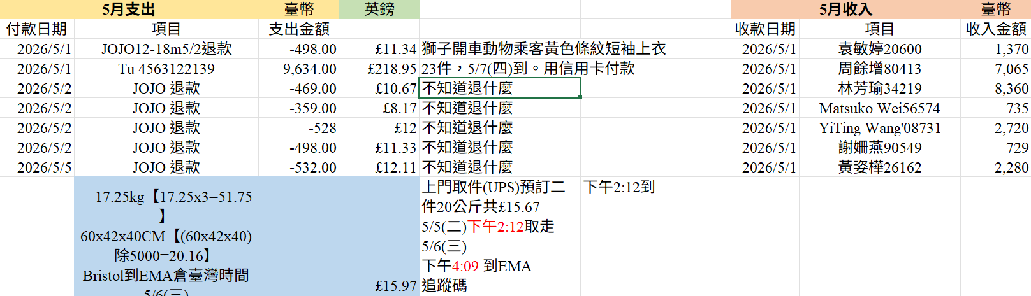
- 營業額與利潤智慧統計報表 (Revenue & Profit Report Dashboard):
  - 中文： 報表頂端需提供日期區間篩選器（可依：訂貨開始/結束日期、到貨開始/結束日期、出貨開始/結束日期、特定月份、訂單狀態）進行數據檢索。
  - English:
- Top-Level Analytical Filter Panel: A specialized reporting filter component must be integrated at the top of the report interface, allowing administrators to execute multi-conditional data retrieval and date-range scoping across the following parameters:
  - Order Date Range: Order Start Date to End Date (訂貨開始/結束日期).
  - Arrival Date Range: Arrival Start Date to End Date (到貨開始/結束日期).
  - Shipping/Dispatch Date Range: Shipping Start Date to End Date (出貨開始/結束日期).
  - Specific Month Lookup: Calendar Month Filter (特定月份).
  - Order Status Toggles: Order Lifecycle Status (訂單狀態).

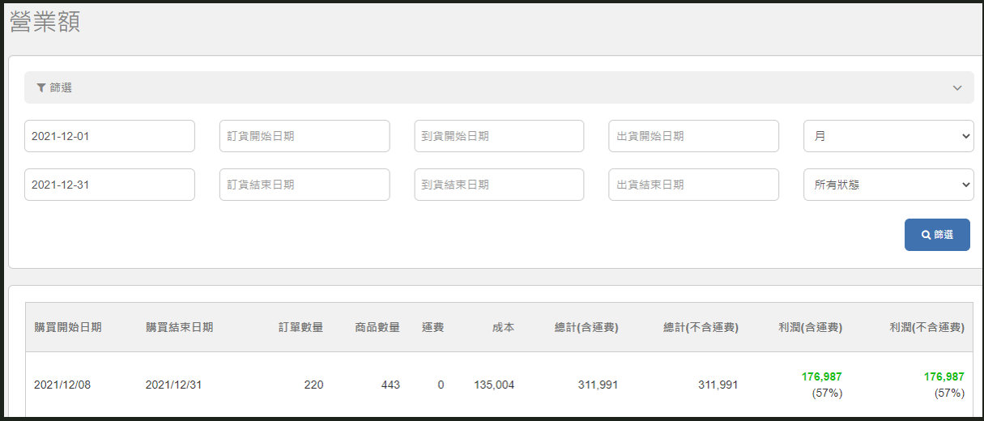
  - 報表表格欄位定義（由左至右）： 購買開始日期 ＞ 購買結束日期 ＞ 總訂單數量 ＞ 總商品件數 ＞ 運費成本 ＞ 採購商品成本 ＞ 總計銷售額（含運費） ＞ 總計銷售額（不含運費） ＞ 總淨利潤（含運費） ＞ 總淨利潤（不含運費） ＞ 客單價（計算公式：銷售額除以總訂單數量）。
English:
- Sequential Report Columns (From Left to Right): The data grid for the analytical reports must present the following metric columns sequentially from left to right:
  - Purchase Start Date (購買開始日期)
  - Purchase End Date (購買結束日期)
  - Total Order Count (總訂單數量)
  - Total Item Count / Volume (總商品件數)
  - Shipping Costs (運費成本)
  - Procurement Product Costs (採購商品成本)
  - Gross Sales Revenue (Including Shipping) (總計銷售額 - 含運費)
  - Gross Sales Revenue (Excluding Shipping) (總計銷售額 - 不含運費)
  - Total Net Profit (Including Shipping) (總淨利潤 - 含運費)
  - Total Net Profit (Excluding Shipping) (總淨利潤 - 不含運費)
  - Average Order Value (AOV) (客單價)
    - Programmatic Formula: \text{AOV} = \frac{\text{Gross Sales Revenue}}{\text{Total Order Count}} (客單價計算公式：銷售額除以總訂單數量)

